**MediSave Accreditation**

**Accreditation Process and Submission of Bank Forms to CPF Board**

**July 2024**

Table of Contents

**1. Accreditation Process Flow Chart For Medical Institutions (MIs)** 3

**2. CPF Board Contact Details on Accreditation Matters** 4

**3. Submission of Bank Forms required by CPF Board** 5

**3.1**  **DDA Form - Pay MediSave Refunds and Interest Using Direct Debit Authorisation (SAMPLE)** 6

**3.2** **DDA Form - Pay Financial Penalty / Interest (SAMPLE)** 7

**1. Accreditation Process Flow Chart For Medical Institutions (MIs)**

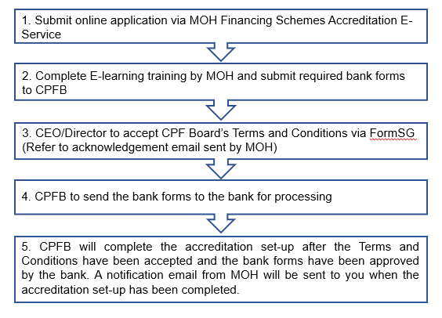

Note: Banks may take up to 4 weeks for processing of the bank forms. The accreditation process may take longer should there be any delay between steps 2 and 5.

**2. CPF Board Contact Details on Accreditation Matters**

|  |  |
| --- | --- |
| **Contact Details** | |
| Mailing Address  (For mailing of bank forms) | Healthcare Claims and Payments Department  (MediSave/MediShield Life Accreditation) Central Provident Fund Board  238B Thomson Road  #08-00 Tower B Novena Square  Singapore 307685 |
| Write To Us | <https://www.cpf.gov.sg/service/write-to-us> |

# **3. Submission of Bank Forms required by CPF Board**

You will need to complete a total of **TWO** bank forms as part of your Medical Institution (MI)’s participation under the MediSave/MediShield Life Schemes. They are as follows:

|  |  |  |
| --- | --- | --- |
| **Name of Bank Form** | **Purpose** | **Form** |
| 1. Pay MediSave Refunds and Interest Using Direct Debit Authorisation (Form MED/DDA) | For CPF Board to debit the MI’s bank account for MediSave refunds and interest owed by the MI  Note: CPF Board will also credit any MediSave/ MediShield Life payment to the MI to this bank account. |  |
| 1. Pay Financial Penalty/ Interest Using Direct Debit Authorisation (Form AFP/DDA) | For CPF Board to debit the MI’s bank account for administrative financial penalty or interest for the late payment of the penalty imposed on the MI. |  |

The following pages will show you templates of the bank forms to submit. You may “Ctrl + click” each number (e.g. **①**) on the template bank forms and be directed to relevant pages for the explanation of each field or where the information may be obtained.

Please submit the two **original** and signed DDA forms to CPF board at our mailing address:

Healthcare Claims and Payments Department

(MediSave/MediShield Life Accreditation)  
Central Provident Fund Board

238B Thomson Road

#08-00 Tower B Novena Square

Singapore 307685

.

## **3.1** **DDA Form -** **Pay MediSave Refunds and Interest Using Direct Debit Authorisation** **(SAMPLE)**

 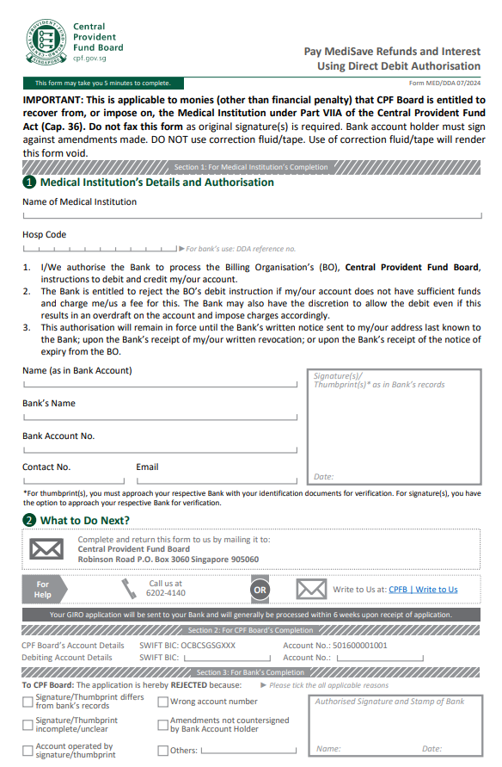

## **3.2** **DDA Form - Pay Finan****cial Penalty / Interest** **(SAMPLE)**

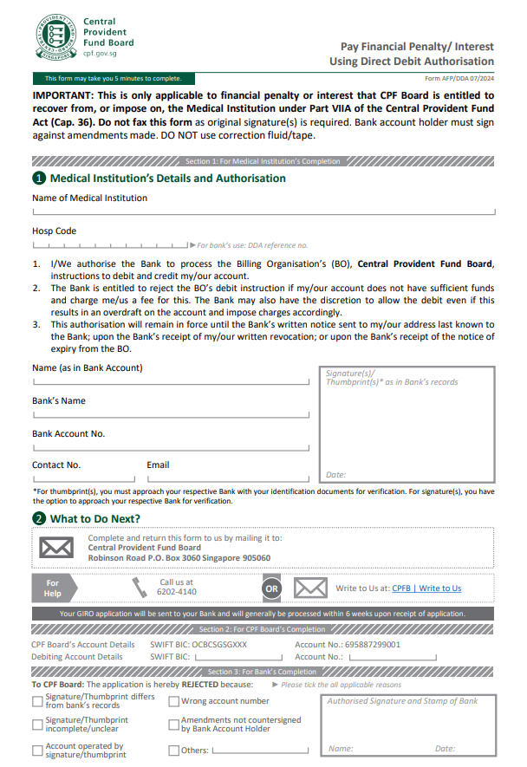

|  |  |
| --- | --- |
| **DDA Forms (For both MediSave Refunds and Interest and Financial Penalty)** | 1. Name of Medical Institution  This is the name of the Medical Institution as stated on the MOH License (refer to the *Name of Premises*). 2. Hosp Code Refers to MI’s assigned Hospital Code. Leave this field blank if you do not know MI’s assigned Hospital Code.  1. Name (as in Bank Account) The Account Name that is registered with the bank for business transactions.   *Note: The name of the bank account for Incorporated Business (Pte Ltd) should be the company’s name (e.g. ABC Dental Pte. Ltd.) and not a personal bank account.*  *For Sole-proprietorship and Partnership, it may be the business owner’s or clinic’s or partners’ name (e.g. Anne Lim).*   1. Bank’s Name Name of MI’s registered bank.  1. Bank Account No. The Bank Account number according to the bank’s record.  1. Contact number The contact number of the person-in-charge (PIC) of the MI’s application for MediSave accreditation, billing and/or general administrative matters.  1. Email The company’s / MI’s email address and/or its PIC.  1. Signature/ Thumbprint (as in Bank’s record)   Signature(s) / thumbprint of authorised person according to the bank’s records. |